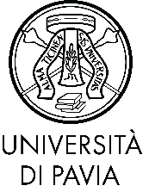
Pavia Intensive School for Advanced Graduate Studies
Western dramaturgy from Antiquity to today
University of Pavia
6 - 10 September 2021

Participation Form

Surname and name _____________________ ______________________________
Date and place of birth __________________________________________________
District _____________ City _____________
Personal ID/VAT number ________________________ Nation _____________
Address ___________________________ Street number ________ Zip code _______
District _____________ City _____________
Email _______________________________________
University ____________________________________________________________
Modes of participation
Presence
Remote
Workshop option
Verbatim drama workshop - Vera Cantoni
Playing the stage - Stefano Vizioli

The form needs to be compiled and forwarded to Dr. Davide Cioffrese (davide.cioffrese@unipv.it)
no later than 22 August 2021.

